GUÍA DE APRENDIZAJE 1-ACTIVIDADES 1

1. THE – DO YOU PRONOUNCE / ∂ / OR / i / ? Escriba la pronunciación, use ∂ or i

|  |  |  |
| --- | --- | --- |
| 1 The United States _i__  2 The MTV _∂__  3 The correct answer ___  4 The end ___  5 The Universe ___  6 The Earth ___  7 The Atlantic Ocean ___ | 8 The Mediterranean ___  9 The air we breathe ___  10 The heir to the throne___  11 The hours we waste ___  12 The BBC ___  13 The human race ___  14 The animals ___ | 15 The yellow lines ___  16 The water we drink___  17 The United Kingdom___  18 The Golden Gate___  19 The Europeans ___  20.The Old Soviet Union__ |

1. **Fill in the correct word (*some* or *any*).**
2. Sue went to the cinema with  of her friends!
3. Jane doesn't have  friends.
4. Have you got  brothers or sisters?
5. Here is  food for the cat.
6. I think you should put  flowers on the table.
7. Could you check if there are  calls on the answering machine?
8. I don't want  presents for my birthday.
9. Did they have  news for you?
10. I'm hungry - I'll have  sandwiches.
11. There aren't  apples left.

**3. Put in a or an where necessary.**

1. Mary likes __ jam on __ piece of __ bread. 2. __ cow eats __ grass in _ spring.

3. ___ bread is made from __ flour.

4. We eat __ soup with ___ spoon.

5. She likes __ tea with _ lemon.

6. __ farmer has much work this summer.

7. ___ sweater is made of __ wool. 8. We have got __ lot of friends.

8. There is __ red apple on the plate.

9. __ big fish was swimming in __water.

10. He is __ student.

**4. Turn these sentences into negative.**

1. She is a young girl.
2. I am a detective.
3. They are ugly cats.
4. We are strong girls.
5. Steven is from England.
6. You are a nurse.
7. He’s a basketball player.
8. They are bottles.
9. That is a fish.
10. The black cat is small.
11. This boy is lazy.

**5. Read and complete**.

1. ......she a dancer? No,................
2. .......they from Japan? Yes,..........
3. .......he a bus driver? No,.............
4. .......it a pet? No,....................
5. .......they dirty? Yes,..................
6. .......Mary from Italy? No,............
7. .......Mr Dane a doctor? Yes,.........
8. .......that Kim? No,....................
9. .......you a pilot? No,..................
10. .......they penguins? Yes,..............
11. .......you dancers? Yes,................
12. .......they brown? No,..................

**6. Correct the mistakes in these sentences:**

1. Sarah and I am sisters.
2. Ben and Tim is at school.
3. Horses and cows is animals.
4. England are a country.
5. Tim are from America.

**Motorbike Vocabulary Builder**

1. **Instructions**: **Draw a line from the vocabulary word to its corresponding location on the motorbike.**

Seat, Rearview-Mirrors, Turn signals, Headlight, Speedometer. Breaks, Handgrip

Kickstand, Wheels, Tires, Muffler Break light, Rear carrier, Footrest

1. **Instructions**: **Fill in the blank spaces using your new vocabulary words.**
2. Squeeze the __________ when you want to stop.
3. Turn on the _____________ if you are riding at night.

3. Be careful not to touch a hot ___________, you might get burned.

4. Use the _____________ to park the motorbike.

5. To see how fast you are going, look at the ______________.

1. **Draw a line from the vocabulary word to its corresponding location on the helmet.**

Helmet shell, ventilation, EPS liner, interior System, chinstrap, shield

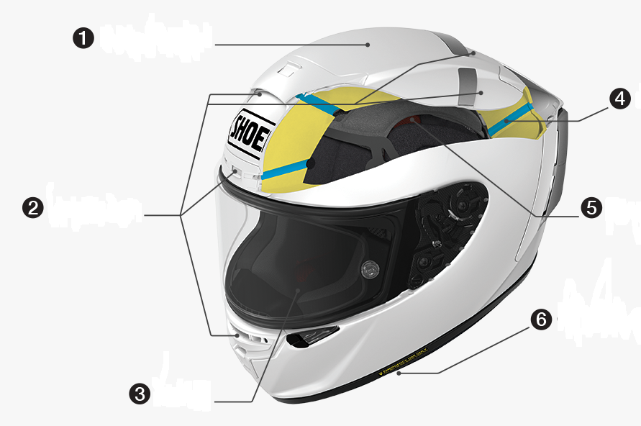

1. **Write other protective elements using by motorcyclists for that enter to this link and looking for:** <https://www.motorcycleid.com/chest-back-protection.html>
2. **Write the meaning of:**

* Motorcycle
* Motorcyclist
* Motorcycling